Table of Contents

1 Table of Figures 1

2 Table of Tables 1

3 Table of Equations 1

4 Subsystem Two: Force applied by and to Exoskeleton 2

4.1 Requirements and Functional Decomposition 2

4.2 Background and Prior Art 3

4.3 Approach and Execution 3

4.4 Results and Discussion 7

5 Bibliography 8

# Table of Figures

Figure 22: SS2 Breakdown 2

Figure 23: YZC-161B - 50kg Load Cell (ZJIA, 2018) 3

Figure 24: YZC-161B Wire Configuration 3

Figure 25: Load Cell Configuration 4

Figure 26: Load Cell Topology 4

Figure 27: INA125 - Instrumentation Amplifier 5

Figure 28: Load Cell Amplifier Topology 5

Figure 29: Load Cell Calibration Data 6

Figure 30: Force Sensor Configuration 7

# Table of Tables

Table 2: Load Cell Calibration 7

# Table of Equations

Equation 1: INA125 Gain 6

# Subsystem Two: Force applied by and to Exoskeleton

This section details the analysis, design, implementation, and results of the subsystem responsible for the perception of the applied by the exoskeleton to the environment and by the pilot to the exoskeleton.

## Requirements and Functional Decomposition

The overarching purpose of subsystem two (SS2) is to measure the force applied to the internals and externals of the suit.

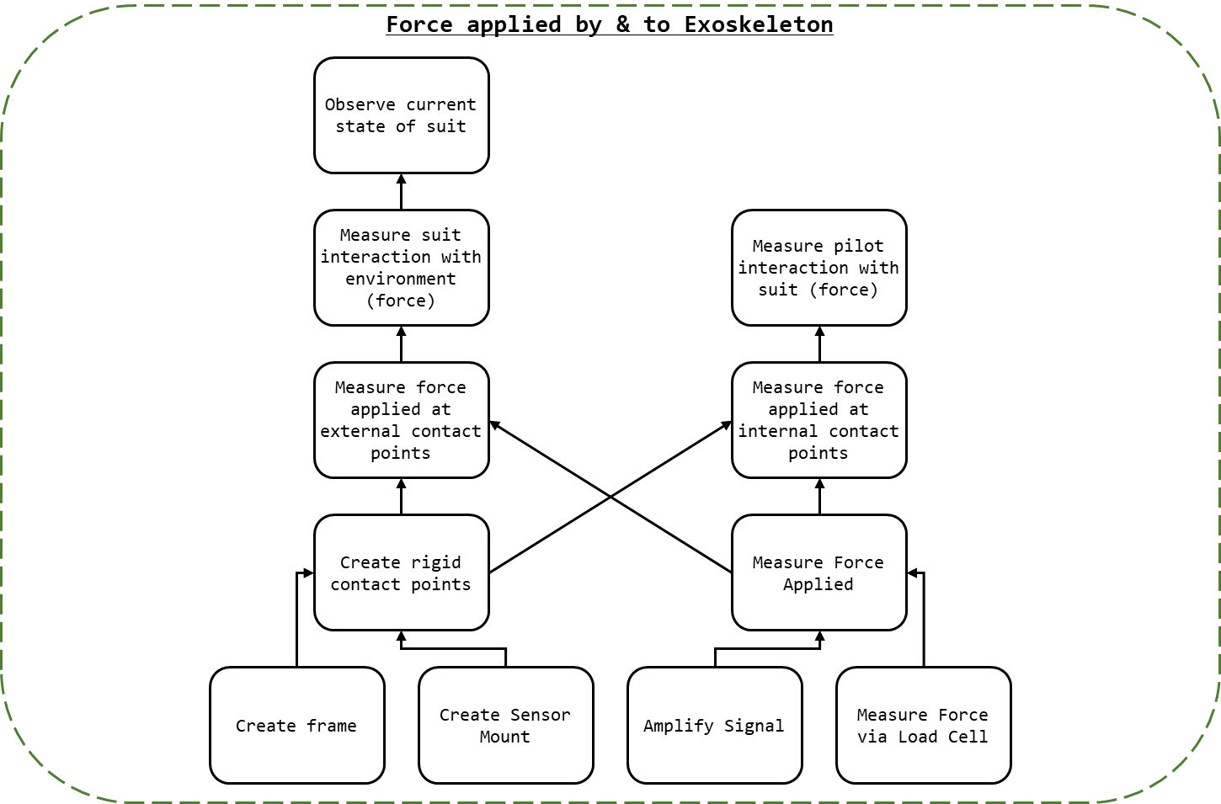

Figure 1: SS2 Breakdown

As seen in Figure 1: SS2 Breakdown, to measure the force applied to the suit at the designated contact points (feet and upper thigh) the following was required:

* Creating of rigid contact point upon which force application could be measured;
  + This would require a rigid frame upon which sensors could be mounted; and,
  + Mounts for force sensors.
* Measuring the force applied to the surface; and,
  + This would involve measuring the force applied via load cell; and,
  + Amplifying the signal from the load cells.
* The measured distance must be parsed from raw values into useable data.
  + functionally, this is the process of deriving the function that maps raw analogue voltage values to force.

## Background and Prior Art

### Load Cells

Transducers are “elements that convert from one form of energy to another for example, sound to electricity” (Agarwal, 2005). A load cell is a type of transducer that converts the application of force or pressure into voltage or a change in imprudence. A load cell may be effectively used to measure the force applied to a surface, and the fundamental technology behind the common bathroom scale.

## Approach and Execution

### Measure Force

Load cells would be used to measure the force application to the contact points. Load cells allow for the précised measurement of force application in real time. Given the weight of the individuals associated with the project and preliminary estimations of the exoskeleton mass it was assumed that the mass for the entire system and pilot would not exceed 150 kg. Due to the incrementation of load cell ratings, 200 kg (four 50kg load cells) were selected. As seen in Figure 2: YZC-161B - 50kg Load Cell (ZJIA, 2018), the YZC-161B 50kg (coincidentally the load cell used in bathroom scales) is a flat strain-gauge type load cell specifically rated for human mass measurement.

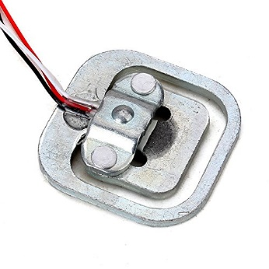

Figure 2: YZC-161B - 50kg Load Cell (ZJIA, 2018)

The YZV-161B’s datasheet may be found in the attached documents as “YZC-161B - 50kg Load Cell.pdf”. The designation of each wire for the YZC-161B may be found in Figure 3: YZC-161B Wire Configuration.

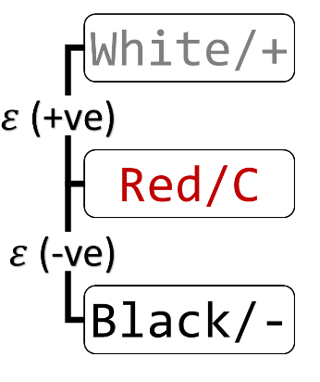

Figure 3: YZC-161B Wire Configuration

Four YZC-161B were wired in Wheatstone bridge configuration as shown in Figure 4: Load Cell Configuration.

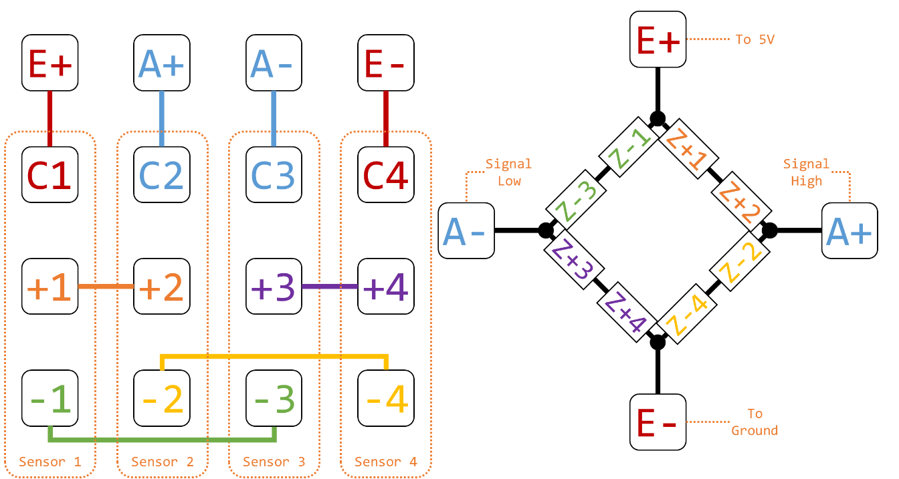

Figure 4: Load Cell Configuration

The configuration shown in Figure 4: Load Cell Configuration was implement in the PCB design of the controller boards, detailed in kt, in the schematic shown in Figure 5: Load Cell Topology, where B and T refer to the external and internal (bottom and top) load cell sets respectively.

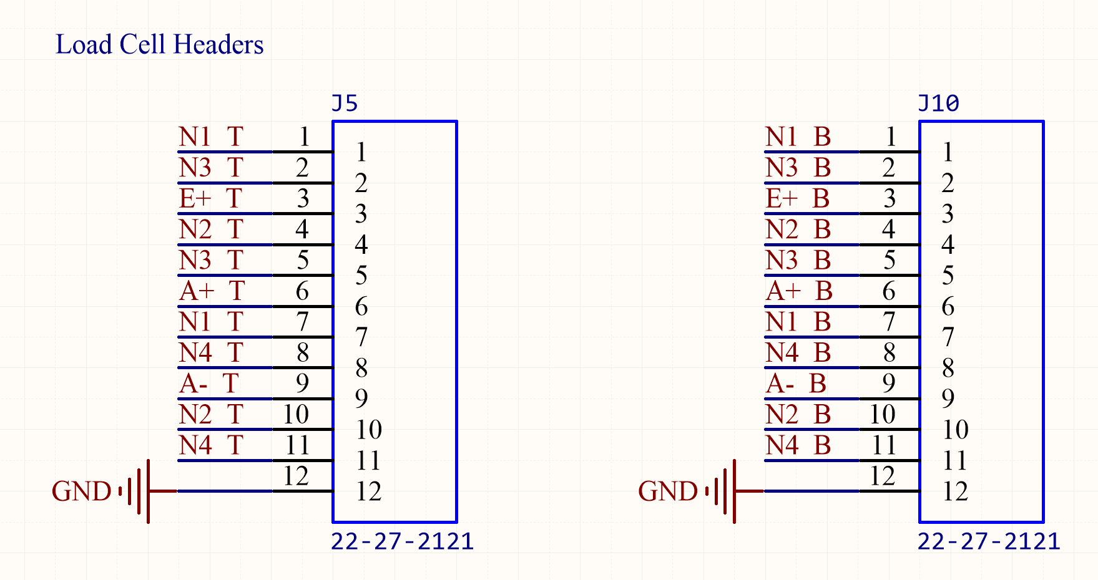

Figure 5: Load Cell Topology

### Amplify Signal

To measure the signal output by the Wheatstone bridge configuration an instrumentation amplifier was used. The amplifier selected was the INA125, as seen in Figure 6: INA125 - Instrumentation Amplifier.

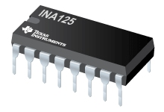

Figure 6: INA125 - Instrumentation Amplifier

The INA125’s datasheet may be found in the attached documents as “INA125 - Instrumentation Amplifier With Precision Voltage Reference.pdf”. The INA125s in the project were wired as depicted in Figure 7: Load Cell Amplifier Topology.

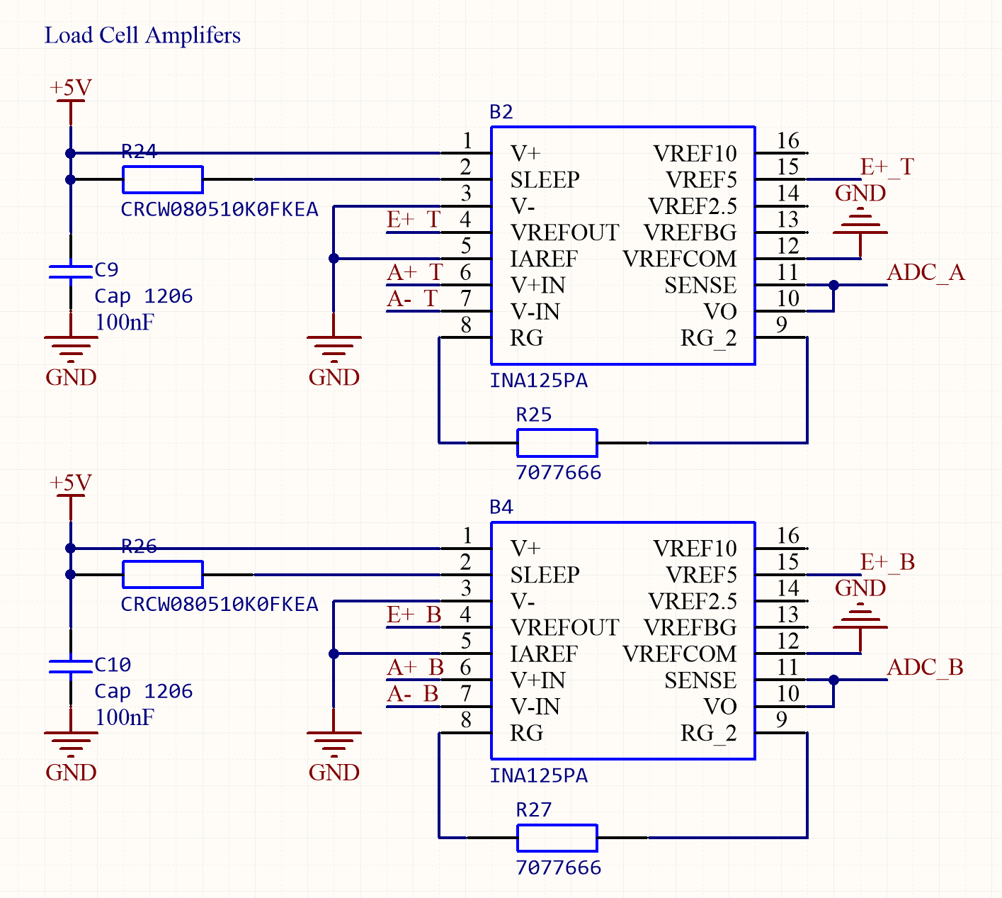

Figure 7: Load Cell Amplifier Topology

The INA125 allows for adjustable gain determined by the value of $R_{G}$, shown as R25 and R27 in Figure 7: Load Cell Amplifier Topology. The gain of the amplifier was given by Equation 1: INA125 Gain.

$$G=4+\frac{60 kΩ}{R_{G}}$$

Equation 1: INA125 Gain

Alas, the quality control for the YZC-161B was terrible. The gain required could not be determined in advance. This may have been the consequence of buying cheap Shenzhen part. As seen in Table 1: Load Cell Calibration for two sensors set received in the same shipment, fresh from the packaging, the gain required for the same effective range of measurement was approximately ten times greater.

Instead, socket headers were attached to a calibration board in place of resistors (so resistors could be added and removed without soldering). A load cell could hen be attached to the board and calibrated, finding the resistor and gain that was most suitable.

As discussed in kt, the demonstration to be conducted would not include a fully constructed exoskeleton and demonstration rigs were to be created. Consequentially, rather than configuring the load cells for full force range expected by the system, instead the load cells were configured so that the force applied by human hands would be sufficient to trigger a system response.

To calibrate the load cells the following method was used:

1. Tare the load cells by recording the values taken at no weight applied;
2. Place a known weight on the load cells and record the readings;
3. Repeat step 2 with all available known weights; and,
4. Repeat steps 2 and 3 at least 3 times.

The results were then processed, and the relationship between the sensor readings and mass were determined. As seen in Figure 8: Load Cell Calibration Data, the relationship between the voltage output and the mass is linear. Note that the change in resistance of the load cells is directly proportional, and the voltage follows the opposite relationship.

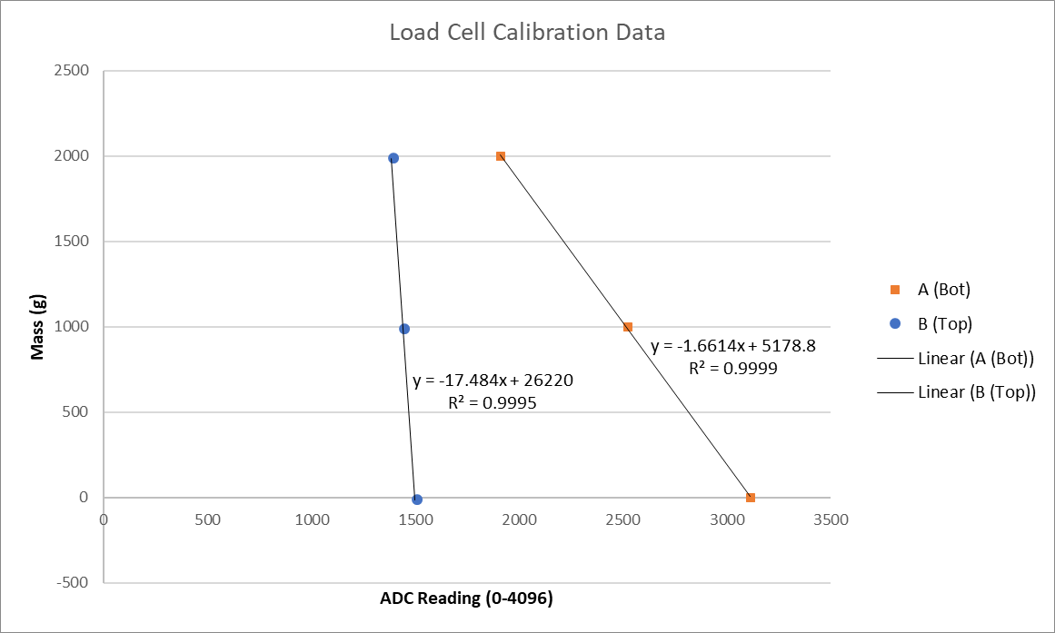

Figure 8: Load Cell Calibration Data

For the load cells used for the demonstration and test B, as detailed in kt (SS5) and kt (integrated) the configuration in Table 1: Load Cell Calibration was used.

Table 1: Load Cell Calibration

|  |  |  |  |
| --- | --- | --- | --- |
| Load Cell Array | $$R_{G}$$ | Gain | Voltage to Mass Function (as enacted in C) |
| Top (Internal) | 4.7 $Ω$ | 12800 | massA = -1.6614 * ADC_A_Value + 5178.8; |
| Bottom (External) | 47 $Ω$ | 1280 | massB = -17.484 * ADC_B_Value + 26220; |

### Mount Sensor

kt

### Rigid Frame

A rigid frame was required to ensure proper demarcation between internal and external force application. The frame was also to serve as the mount for the load cell mounts. Two aluminium plates where used with screw holes as needed. As noted in kt (section above), the load cells sipped did not match their description and feature prefabricated feet; rather than discarding them they were integrated into the design.

The design for the rigid frame with load cells and mounts may be found in Figure 9: Force Sensor Configuration. A rigid centre plate separated the internal and external load cells. A rigid top plate was added to the internal edge of the rig to protect the load cells and ensure an evenly distributed force from the pilot. In the case where the pilot applied force to the environment (A) force applied would be transmitted to the internal load cells, but the external load cells would remain independent (receiving force only from obstacles. In the case were obstacles applied force but the pilot did not, the rigid plate would decouple the force allowing the controls system to indicate a stop condition.

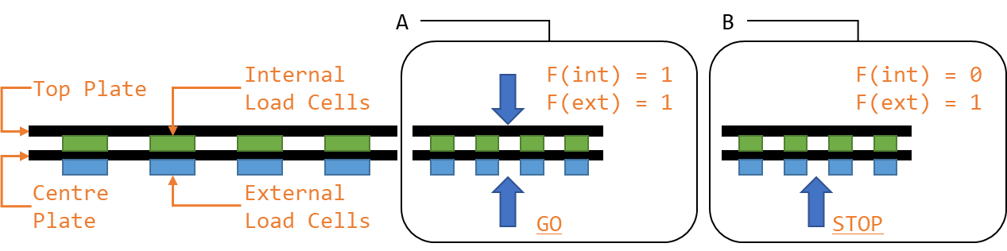

Figure 9: Force Sensor Configuration

## Results and Discussion

Quality control on the YZC is dogshit

Gross vs fine motor control

Redo sensor mounts

# Bibliography

Agarwal, A. (2005). *Foundations of analog & digital electronic circuits* (1 ed.). Massachusetts: Massachusetts Institute of Technology. Retrieved June 1, 2018, from https://www.google.com/url?sa=t&rct=j&q=&esrc=s&source=web&cd=1&ved=0ahUKEwiBu7yQl7LbAhUEoZQKHfYlBzkQFggpMAA&url=http%3A%2F%2Fsiva.bgk.uni-obuda.hu%2Fjegyzetek%2FMechatronikai_alapismeretek%2FEnglish_Mechatr%2FElectr_Eng-1%2FLiterature%2FFoundations%2520o

American Technologies Network Corporation. (2018, May 30). *How Does Night Vision Work*. Retrieved from atncorp.com: https://www.atncorp.com/hownightvisionworks

Arrow. (2018). *Magnetoresistive Sensor.* Retrieved May 30, 2018, from arrow.com: https://www.arrow.com/en/categories/sensors/magnetoresistive-sensors

Axe, D. (2012, May 23). *Combat Exoskeleton Marches Toward Afghanistan Deployment*. Retrieved May 30, 2018, from Wired: https://www.wired.com/2012/05/combat-exoskeleton-afghanistan/

Bulgrin, M. (2017, May 11). *The History of the Hose Clamp.* Retrieved from normagroup.com: https://blog.normagroup.com/en/the-history-of-the-hose-clamp/

Bunnings. (2018, May 31). *Kinetic 21 - 44mm 304 Stainless Steel Hose Clamp.* Retrieved May 31, 2018, from Bunnings.com: https://www.bunnings.com.au/kinetic-21-44mm-304-stainless-steel-hose-clamp_p4920194

Charara, S. (2015, July 9). *This robotic exoskeleton helps paralysed patients to walk and it's getting smarter*. Retrieved August 23, 2017, from Wearable: https://www.wareable.com/wearable-tech/exoskeleton-paralysed-patients-ekso-bionics-gt-sarah-thomas

Computer Cable Store. (2018, May 31). *11 7/8 Inch Black Standard Nylon Cable Tie - 100 Pack.* Retrieved May 31, 2018, from computercablestore.com: https://www.computercablestore.com/11-78-inch-black-standard-nylon-cable-tie-100-pack

Cornwall, W. (2015, October 15). *Feature: Can we build an ‘Iron Man’ suit that gives soldiers a robotic boost?* Retrieved August 20, 2017, from sciencemag.org: http://www.sciencemag.org/news/2015/10/feature-can-we-build-iron-man-suit-gives-soldiers-robotic-boost

Cracknell, A. P., & Hayes, L. (2007). *Introduction to Remote Sensing* (2 ed.). London: Taylor and Francis. Retrieved May 30, 2018

Cutnell, J. D., & Johnson, K. W. (1998). *Physics* (4th ed.). New York: Wiley.

Cyberdyne. (2015, August 1). *CYBERDYNE Inc. has begun seeking approval from the U. S. Food and Drug Administration (FDA)*. Retrieved August 23, 2017, from cyberdyne.jp: https://www.cyberdyne.jp/english/company/PressReleases_detail.html?id=1075

Cyberdyne. (2016). *What’s HAL?* Retrieved August 19, 2017, from cyberdyne.jp: https://www.cyberdyne.jp/english/products/HAL/

Cybernetic Zoo. (2010, October 14). *1890 – Assisted-walking Device – Nicholas Yagn (Russian)*. Retrieved May 30, 2018, from Cyberneticzoo.com: http://cyberneticzoo.com/tag/nicholas-yagn/

Cybernetic Zoo. (2010, April 10). *1965-71 – G.E. Hardiman I Exoskeleton – Ralph Mosher (American)*. Retrieved May 30, 2018, from cyberneticzoo.com: http://cyberneticzoo.com/man-amplifiers/1966-69-g-e-hardiman-i-ralph-mosher-american/

Dawkins, P. (2018). *Differential Equations - Notes - Laplace’s Equation*. Retrieved June 3, 2018, from Paul's Online Math Notes: http://tutorial.math.lamar.edu/Classes/DE/LaplacesEqn.aspx

Dunietz, J. (2017, July 27). *Robotic Exoskeleton Adapts While It’s Worn*. Retrieved August 20, 2017, from scientificamerican.com: https://www.scientificamerican.com/article/robotic-exoskeleton-ldquo-evolves-rdquo-while-its-worn/

Future Electronics. (2018, May 30). *What is Optoelectronics?* Retrieved from Future Electronics: http://www.futureelectronics.com/en/optoelectronics/infrared-receivers.aspx

Garbett, I. (2001, Janurary 1). *Light attenuation and exponential laws*. Retrieved May 30, 2018, from plus.maths.org: https://plus.maths.org/content/light-attenuation-and-exponential-laws

Golnaraghi, F., & Kuo, B. C. (2010). *Automatic Control Systems* (9 ed.). Hoboken: John Wiley & Sons, Inc. Retrieved June 4, 2018

Gross, K. (2018, Feburary 19). *Ultrasonic Sensors: Advantages and Limitations*. Retrieved May 30, 2018, from MaxBotix: https://www.maxbotix.com/articles/advantages-limitations-ultrasonic-sensors.htm/

Jackson, R., Green, K. R., & Eisenbeis, R. (2017). *Achieve greater precision, reliability with integrated magnetic sensing technology.* Retrieved May 30, 2018, from ti.com: http://www.ti.com/general/docs/lit/getliterature.tsp?baseLiteratureNumber=sszy030&fileType=pdf

Karlin, S. (2011, July 29). *Raytheon Sarcos’s Exoskeleton Nears Production*. Retrieved August 11, 2017, from spectrum.ieee.org: http://spectrum.ieee.org/at-work/innovation/raytheon-sarcoss-exoskeleton-nears-produc

Keller, M. (2016, August 25). *Exoskeleton - Do You Even Lift, Bro? Hardiman Was GE’s Muscular Take On The Human-Machine Interface*. (General Electric) Retrieved May 30, 2018, from GE Reports: https://www.ge.com/reports/do-you-even-lift-bro-hardiman-and-the-human-machine-interface/

Keyence Corporation. (2018). *What is a Inductive Proximity Sensor?* Retrieved May 30, 2018, from keyence.com: https://www.keyence.com/ss/products/sensor/sensorbasics/proximity/info/

Khatib, O. (2008). Chapter 5 - Dynamics. In O. Khatib, *Introduction to Robotics* (pp. 125-150). Stanford: Stanford University.

Liew, S. C. (2018, May 30). *Electromagnetic Waves*. Retrieved from Centre for Remote Imaging, Sensing and Processing.: https://crisp.nus.edu.sg/~research/tutorial/em.htm

Lynch, D. K., & Livingston, W. C. (2001). *Color and Light in Nature* (2nd ed.). Cambridge, United Kingdom: Cambridge University Press. Retrieved May 30, 2018, from https://books.google.com.au/books?id=4Abp5FdhskAC&pg=PA231&redir_esc=y#v=onepage&q&f=false

Merriam-Webster Dictionary. (2018, May 18). *noise*. Retrieved May 30, 2018, from merriam-webster.com: https://www.merriam-webster.com/dictionary/noise

National Instruments. (2018). *PID Theory Explained.* Retrieved June 4, 2018, from NationalInstruments.com: http://www.ni.com/white-paper/3782/en/

Ogata, K. (2010). *Modern Control Engineering* (2 ed.). New Jersey, United States of America: Prentice Hall. Retrieved August 25, 2017

Otaga, K. (2004). *System Dynamics* (4 ed.). Upper Saddle River: Pearson. Retrieved June 4, 2018

Robomart. (2015, November 9). *Advantages and Disadvantages of ultrasonic distance sensor.* Retrieved May 30, 2018, from Robomart: http://roboticsensors.blogspot.com/2015/11/advantages-and-disadvantages-of.html

Siciliano, B., & Khatib, O. (2016). *Springer Handbook of Robotics* (2 ed.). (B. Siciliano, & O. Khatib, Eds.) Berlin: Springer Nature. doi:10.1007/978-3-319-32552-1

Texas Instruments Incorporated. (2017). *Hall effect sensors*. Retrieved May 30, 2018, from ti.com: http://www.ti.com/sensing-products/magnetic-sensors/hall-effect/overview.html

Thomas Publishing Company. (2018). *Capacitive Proximity Sensors*. Retrieved May 30, 2018, from Thomas: https://www.thomasnet.com/articles/instruments-controls/proximity-sensors

Vishay Semiconductors. (2017, February 8). TCRT5000 - Reflective Optical Sensor with Transistor Output.

Yagin, N. (1890, February 11). *United States of America Patent No. 440684.*

Yuhas, D. (2012, May 24). *Speedy Science: How Fast Can You React?* Retrieved from scientificamerican.com: https://www.scientificamerican.com/article/bring-science-home-reaction-time/

ZJIA. (2018, June 1). *Generic YZC-161B 50kg Body Scale Sensor Human Scale Weighing Load Cell Sensor (Pack of 4)* . Retrieved June 1, 2018, from Amazon.com: https://www.amazon.com/Generic-YZC-161B-Scale-Sensor-Weighing/dp/B00MTJ6WZ2